

COM 801 Project Elective

PROJECT REPORT

Data Analysis and RAG
Recommendation System
For Compost Monitoring System

Instructor:
Prof. Jyotsna Bapat
and
Prof. Sasirekha GVK

By:
C Siva Kumar
MT2024514

1. Introduction
Objective
Our project focuses on analyzing sensor data from two composting cycles to understand the composting process and build a Retrieval-Augmented Generation (RAG) system for the Compost Monitoring System. The goal is to provide actionable recommendations for optimizing composting efficiency, reducing harmful emissions (NH₃, H₂S, CH₄), and improving compost quality.

Scope
- Data Analysis:
  - Collected and analyzed sensor data from two composting cycles:
    - Cycle 1: Baseline composting process (40+ days).
    - Cycle 2: Improved composting setup with enhanced aeration (40+ days).
- RAG System: Developed a prototype system to retrieve contextually relevant composting guidelines from research papers and generate recommendations.

Parameters Monitored
- Gases: NH₃, H₂S, CH₄ (emissions control).
- Environmental Factors: Soil moisture, ambient temperature, humidity.
- Compost Health: Compost temperature, pH value.
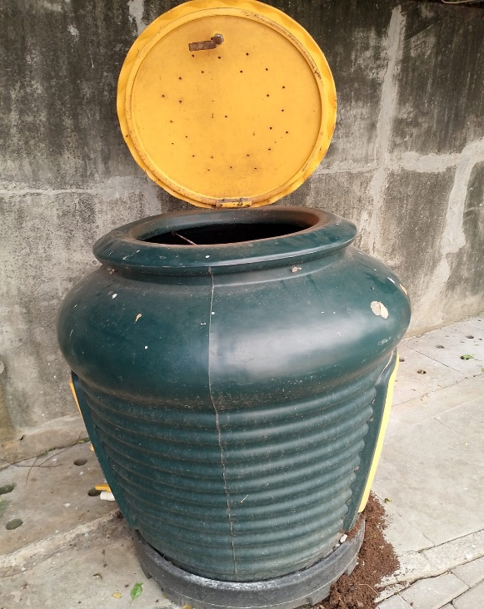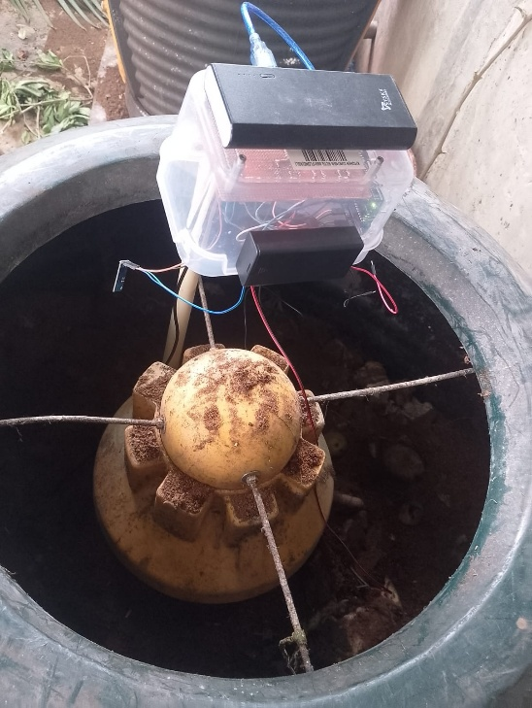
Fig. 1 Composting Bin Setup

2. Part A: Data Analysis

2.1 Data Processing
Data Collection
Sensor data was collected wirelessly using a Raspberry Pi. Daily readings were converted into Excel files via a Python script (this was done by Arun Sir) and later standardized into CSV files.

Preprocessing
- Missing Values: Applied interpolation methods:

Parameter | Method | Reasoning
NH₃, Soil Moisture | Linear | Stable trends over time.
H₂S | Cubic Spline | Captured non-linear fluctuations.
CH₄, pH | Polynomial (Order 2) | Modelled gradual changes in emissions.
Humidity | Linear + Rolling Mean | Smoothed short-term noise.

- Outlier Removal: Used the Interquartile Range (IQR) method. It is also known as Box-Whisker plot.

2.2 Data Aggregation
Aggregated daily sensor readings into two datasets:
- Cycle 1: Baseline composting process.
- Cycle 2: Improved setup with better aeration.
Calculated daily averages for each parameter to reduce noise.

Interpolation methods why and what : https://g.co/gemini/share/407d5c7ab2e1
Full A to Z Data analysis: https://chatgpt.com/share/68a8a738-2430-8012-976a-5df19d221743

2.3 Data Visualization and Insights
Tools: Pandas, Matplotlib, NumPy.
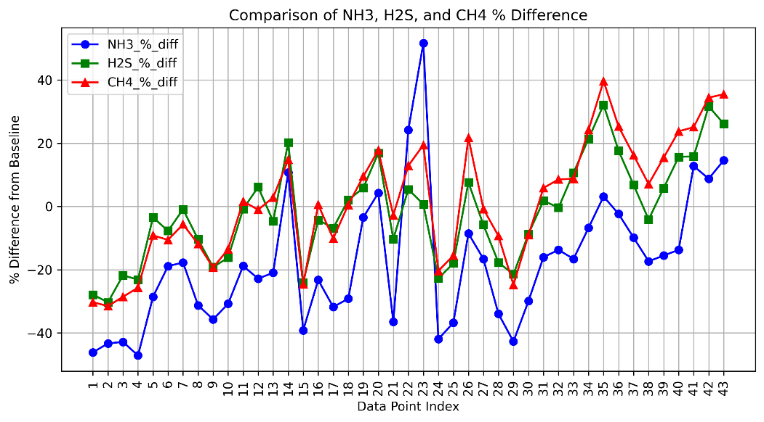
Fig 2. Cycle 1
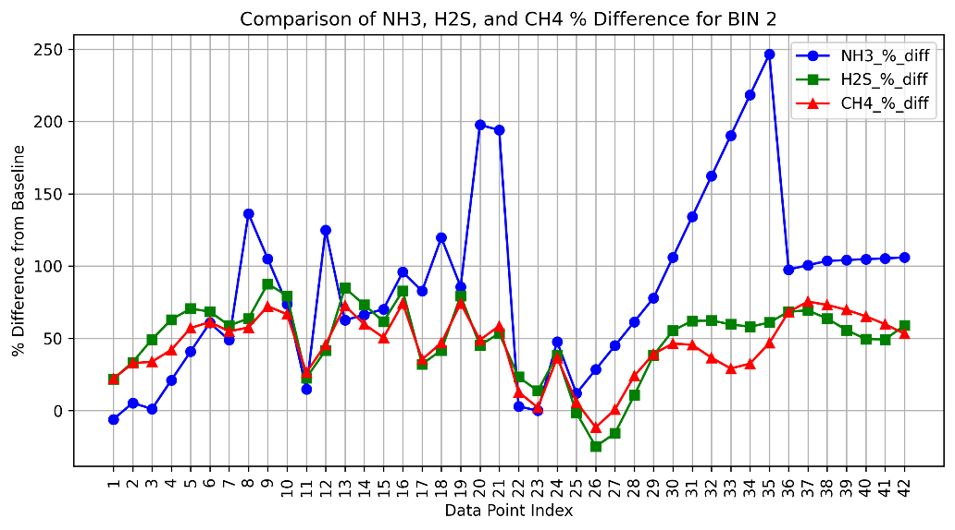
Fig 3. Cycle 2

Key Findings
- Cycle 1:
  - NH₃ and CH₄ correlation: 0.83 (indicating anaerobic conditions).
  - Stalled microbial activity.
  - Insight: Poor aeration slowed decomposition.

- Cycle 2:
  - Compost temperature stabilized at ~30°C by Day 30 (25% faster than Cycle 1).
  - Reduced CH₄ and H₂S spikes.
  - Insight: Improved aeration reduced the anaerobic conditions.

3. Part B: RAG-Based Recommendation System
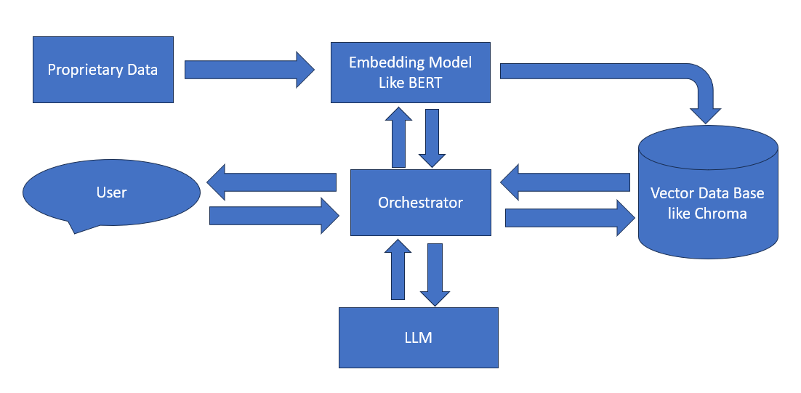

Fig 4. Level 1 diagram of the RAG System

3.1 Data Sources
Scraped composting guidelines from PDFs of research papers related to compost monitoring systems, composting practices etc. stored in Google Drive.

3.2 Data Processing Pipeline
1. Text Extraction
Used pdfplumber python library to preserve document structure.
2. Cleaning
- Removed citations (e.g., "[3]") and URLs.
- Retained section headers using regex.
3. Chunking
Split text into 1,000-character chunks with 200-character overlap using Recursive Character Text Splitter.
4. Embedding
Generated embeddings with BAAI/bge-small-en-v1.5 model.
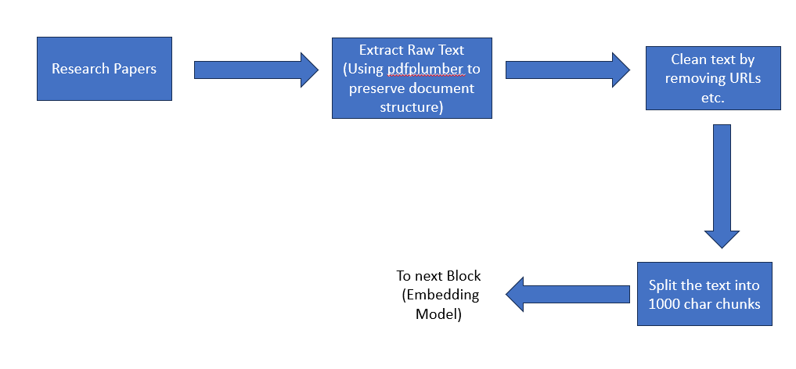
Fig 5. Preprocessing Pipeline

5. Vector Database
Why Chroma?
- Chose ChromaDB for prototyping simplicity:
  - Stores embeddings + metadata (e.g., section titles).
  - Enables fast similarity searches.
  - Persists data to disk for reuse.

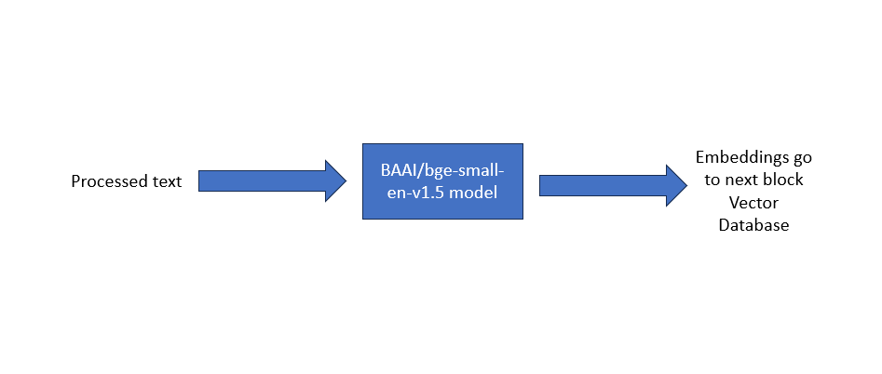
Fig. 6. Creating Embeddings

3.3 Current System Output
- Functional ChromaDB database with 1,200+ text chunks.
- Metadata tags for filtering (e.g., "Aeration", "pH Control").
- Sample query output for retrieving relevant composting guidelines.

4. Conclusion
Data Analysis Insights
Cycle 2 demonstrated a 25% faster composting time with improved aeration, validating its role in emission reduction.
RAG System Progress
Built an end-to-end pipeline for knowledge retrieval.
Next Steps:
- Integrate LLMs (e.g. GPT-4 or pen source ones like Llama) for natural language recommendations.
- Link sensor data trends to real-time advice (e.g., pH adjustments).
- Scale with MongoDB/Milvus/Qdrant for production.

Final Notes
This project combines data-driven composting analysis with AI-powered recommendations, offering a sustainable waste management blueprint.

